Module-5 Automation &selenium

1)What is Automation Testing?

Automation Testing is the method of testing software products with special testing tools and frameworks to minimize human intervention and maximize quality.

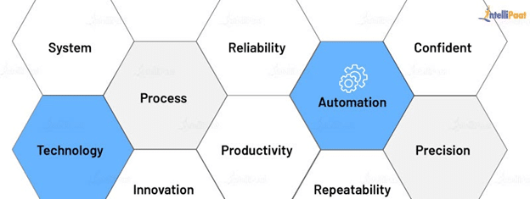

Automation Testing is done with the help of automation software, and it controls the flow of the execution of tests as per the written test scripts. They are then compared with predicted outcomes to ensure the quality and reliability of the application. With Automation Testing, one can perform necessary repetitive tasks and those tasks that are hard to achieve with manual testing. Therefore, this type of testing is critical for CI/CD pipelines.

2)Which Are The Browsers Supported By Selenium Ide?

supported the following two browsers:

* Firefox Browser
* Chrome Browser

So, latest version of Selenium IDE can be installed on both Firefox Browser and Chrome Browser

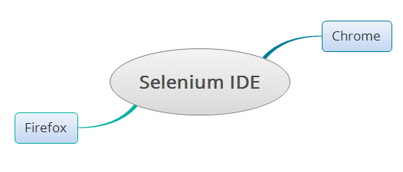

 Where as the older version of Selenium IDE used to support only the below browser:

* Firefox Browser

**Different Browsers Supported by Selenium WebDriver:**

Selenium WebDriver supports all the below mentioned famous browsers in the market:

* Firefox Browser
* Chrome Browser
* Explorer Browser
* Safari Browser
* Edge Browser
* Opera Browser

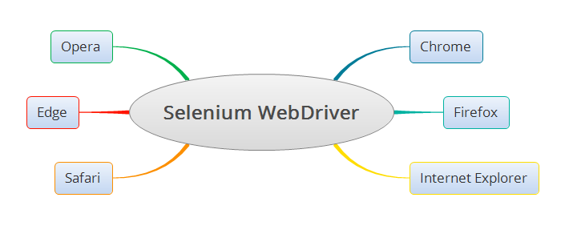

3)What are the benefits of Automation Testing?

## **Benefits of Automated Testing**

In the modern world, automated testing has transformed software development, and it has been the main reason for the explosion of apps over the past decade. Let’s look at the major benefits of automated testing that helps organizations speed up their testing and development processes.

### **1. Faster Feedback Cycle**

With test automation, organizations can reduce the time needed to complete a feedback cycle for new software features. If the testers can provide input about the software to the development team faster, then the development team can fix the bugs in the code more quickly. By increasing the speed of the feedback cycle, companies can eliminate the risk of releasing buggy software. As test automation helps testers detect software bugs in the early stages, they can correct those bugs in the development stage itself. Thus, this will accelerate the software development process.

### **2**. **Testing on Multiple Platforms in Parallel**

Cross-browser compatibility is an important feature that needs to be checked during the software development process. As many browsers are available in the market, manually testing software on all browsers manually is a tedious process. With test automation tools, testers can create countless test cases to perform [cross-browser testing.](https://www.headspin.io/solutions/cross-browser-testing) Hence, the testing team can complete the cross-browser testing of a software application on various browsers, operating systems, and devices quickly and simultaneously.

### **3.** **Reusability of Test Scripts**

As developing test cases take a lot of time and effort, the reusability of test scripts is a major advantage of automated testing. In order to test new operating systems or devices, testers always have to [create distinct test scripts](https://www.headspin.io/blog/how-to-write-an-automated-test-script-using-selenium) for each cross-browser test. The reusability of automated test scripts enables testers to optimize their time better while testing.

An advantage of using Appium and HeadSpin together while automating the testing procedure is recording testers' actions and translating them into code snippets, which they can use in their scripts. This feature will help minimize the effort of manual coding.

### **4.** **Easy Data-driven Testing**

One of the critical benefits of test automation is data-driven testing. With data-driven testing, testers can evaluate all functionalities involving numerous data sets. Some of the significant advantages of data-driven testing that help testers to accelerate the application delivery pipeline include:

* Enables the reuse of functions and actions in testing
* Stores verification and test data in a single file and separates them from the test case logic
* Minimizes the number of test scripts and cases
* Saves all test scripts in a single repository

Data-driven analysis is one of the prime features of the HeadSpin Platform. With our Platform, enterprises can collect 120+ data points to [analyze the performance](https://www.headspin.io/solutions/performance-optimization) and experience of their applications.

### **5**. **Test Insights**

While testing applications manually, testers need to share the inputs of the tests with each other manually to understand how many test scripts have been written and what all errors have been fixed. This can create confusion among the testers and delay the whole testing process. The test insights generated using test automation tools can guide the testing teams in tracking the entire process. With these automatically generated insights, technical teams can reduce the possibility of human errors. Testers can also use these insights to plan their testing process upfront.

### **6**. **Maximum Test Coverage**

Achieving 100% test coverage for complicated applications is very challenging for testers. In manual testing, this becomes more difficult, as it is hard to manage many test cases simultaneously. Automating the testing processes can be an apt solution to this problem. Test automation tools can support the testers by providing additional test coverage and assisting them in testing features like UI, databases, and servers. These tools will enable testers to improve the quality of applications without affecting the functionality. Moreover, with 100% test coverage, testing teams can analyze the previous and current releases and track every build cycle and project fixes.

### **7**. **24X7 Test Execution**

Compared to manual testing, the significant benefit of test automation is the flexibility to perform testing at any time of the day. As manual testing requires human efforts, it is impossible to execute tests 24X7. Automated testing enables testers to schedule automated test execution remotely at any time of the day. With the help of automated testing tools, testing teams can generate detailed reports with insights into the tests that have been run for the analysis of applications at any time of the day as per their convenience.

Also check: [How ReportPortal Helps Continuous Integration and Testing Processes](https://www.headspin.io/blog/reportportal-integration)

### **8**.**Scalability**

When organizations have to perform a large number of test cases manually, they need to expand their workforce accordingly. However, in the case of automated testing, the process is highly scalable, as most of the testing is done automatically. Even though the testing is performed automatically, minimal human supervision is required in this process. According to the [World Quality Report (2021-22)](https://content.microfocus.com/world-quality-report-tb/world-quality-report-2021-22?utm_source=techbeacon&utm_medium=referral&utm_campaign=7014J000000dVOkQAM&_ga=2.59768749.1632633573.1654680411-696412288.1653634814), an efficient and scalable test automation strategy uses AI/ML for dynamic scope selection, detects errors and code backlogs, improves test coverage, and offers better control and transparency over the testing process while reducing test cycles, security concerns, and risks.

### **9. Low Business Costs and Better Utilization of Human Resources**

Although automating the testing processes can be a large investment for enterprises, it can reduce their overall operational cost through effective resource utilization. With test automation tools, companies need a very small workforce to perform the testing process. As there is a lack of workforce for performing the high-level tasks for companies, such as planning and product management, companies can utilize their workforce to perform such tasks. These factors will help organizations to achieve better efficiency and profitability.

### **10. Enhance the Quality of Manual Testing**

Test automation is not an alternative to manual testing, as many testing processes require human supervision and effort. However, automating certain tasks can definitely help testers to improve the quality of applications and reduce the time to market. Most test automation software tools are used to validate manual testing. The major advantage of automation testing is the easing of stressful activity of manual testers, so they get time and bandwidth for innovating with better test scenarios. Thus, manual testing is always the base for test automation.

### **11. Effective Smoke Testing**

Although smoke testing is recommended as a best practice in the testing process, many organizations avoid it to improve the bandwidth of testers. Test automation tools are used to automate smoke testing that needs human efforts. Thus, test automation helps testers evaluate the stability of a software build by performing automated smoke testing for successful build validation. The datasets required for performing smoke tests are generated automatically, thus, allowing the stability of software builds to be determined faster.

### **12**. **Better Regression Testing**

Performing manual [regression testing for applications](https://www.headspin.io/blog/regression-testing-a-complete-guide) is a tedious process. In this type of testing, testers need to repeatedly test a set of similar test cases to ensure that error is fixed. This has been a critical pain point for developers/testers for a long time. Repeated testing can create a delay in the software release and reduce the efficiency of testers. Automated regression testing is the perfect solution for this problem. As test automation tools can perform testing 24X7, the time needed for performing regression testing can always be extended. The time and effort used to build automated test cases is a one-time investment, which will help organizations to increase their profitability.

With HeadSpin’s automated regression testing, QA experts can compare their applications build-over-build. Our solutions will help testing teams reduce the overall regression cycle time and cost involved in the testing process.

### **13. Reduce the Time to Release**

One of the main benefits of test automation is speeding up application development cycles. By automating the testing process, testers are able to test new features very quickly. As automated testing can reduce the time taken to complete feedback cycles, strong inter-departmental communication is established across the test environment. With proper feedback being communicated effectively, each team is able to speed up their process. Thus, this will result in the reduction of applications' time to release.

### **14. Execute Lengthy Test Scenarios**

While performing manual testing, various test scenarios may have recurring and lengthy procedures. By using test automation software tools, testers can execute exceedingly complicated and lengthy test scenarios easily and rapidly 24X7. With automated testing scripts, testers can complete long test scenarios in lesser time compared to manual testing.

### **15. Achieve Excellent Return on Investment (ROI)**

With only manual testing, software development teams take considerable time to develop and launch applications. Moreover, due to repetitive manual quality tests, there can be a delay in the release of the software or its feature. These factors can affect the return on investment of organizations. Automated testing can shorten the product release time by automating all repetitive operations and requiring fewer resources, thus, resulting in a high return on investment.

4)What are the advantages of Selenium?

**Advantages:**   
  
1. Selenium is pure open source, freeware and portable tool.   
2. Selenium supports variety of languages that include Java, Perl, Python, C#, Ruby, Groovy, Java Script, and VB Script. etc.   
3. Selenium supports many operating systems like Windows, Macintosh, Linux, Unix etc.   
4. Selenium supports many browsers like Internet explorer, Chrome, Firefox, Opera, Safari etc.   
5. Selenium can be integrated with ANT or Maven kind of framework for source code compilation.   
6. Selenium can be integrated with TestNG testing framework for testing our applications and generating reports.   
7. Selenium can be integrated with Jenkins or Hudson for continuous integration.   
8. Selenium can be integrated with other open source tools for supporting other features.   
9. Selenium can be used for Android, IPhone, Blackberry etc. based application testing.   
10. Selenium supports very less CPU and RAM consumption for script execution.

5)Why testers should opt for Selenium and not QTP?

| **Selenium** | **QTP** |
| --- | --- |
| Selenium is an Open source tool hence no license required. | License is required. |
| It is a set of APIs. | It is a type of desktop application. |
| There is a Low resource consumption during test scripts execution. | In QTP there is a High resource consumption. |
| There is a customer support in Selenium that is dedicated HP support. | There is a customer support in QTP that is selenium community forums |
| There is relyment for parameterization on any one of the supported programming language. | For parameterization in QTP, built-in tools are available. |
| Some supported environments in Selenium are Android, iOS, Windows, Linux, Mac, Solaris. | QTP supports only Windows. |
| It supports automation for web based applications | There is a support for test on both web and desktop based applications. |
| Java, C#, Ruby, Python, Perl, PHP and JavaScript are the programming languages supported in selenium. | QTP supports VB Script. |
| For generating the reports of test, selenium rely on external tool. | There is built-in test report generation within the tool QTP. |
| All additional plugins are allowed in Selenium. | In QTP, it supports SAP, Oracle and includes no add-ons to the software |
| Object Repository is absent in selenium. | There is a build-in object repository in QTP. |
| Recovery Scenario is absent in selenium. | There is a build-in recovery scenario in QTP. |
| Browsers supported by selenium are Google Chrome, Mozilla Firefox, Internet Explorer, Edge, Opera, Safari, etc. | Browser supported in QTP are specific versions of Google Chrome, Mozilla Firefox and Internet Explorer. |
| Selenium is less user friendly. | QTP is user friendly. |
| Tests can be executed in multiple platforms like Netbeans, Eclipse and Visual Studio. | Tests are only compatible with QTP IDEs. |
| The speed of automation when using Selenium is slower when compared with QTP. | The speed of automation when using QTP is faster when compared with Selenium. |
| It does not have technical support services. | It has technical support services. |

6)To validate the tops technologies website Contact us page and enter your friend detail at last “Guest Call Back” <https://www.tops-int.com/contact-us/>

**// Generated by Selenium IDE**

**import org.junit.Test;**

**import org.junit.Before;**

**import org.junit.After;**

**import static org.junit.Assert.*;**

**import static org.hamcrest.CoreMatchers.is;**

**import static org.hamcrest.core.IsNot.not;**

**import org.openqa.selenium.By;**

**import org.openqa.selenium.WebDriver;**

**import org.openqa.selenium.firefox.FirefoxDriver;**

**import org.openqa.selenium.chrome.ChromeDriver;**

**import org.openqa.selenium.remote.RemoteWebDriver;**

**import org.openqa.selenium.remote.DesiredCapabilities;**

**import org.openqa.selenium.Dimension;**

**import org.openqa.selenium.WebElement;**

**import org.openqa.selenium.interactions.Actions;**

**import org.openqa.selenium.support.ui.ExpectedConditions;**

**import org.openqa.selenium.support.ui.WebDriverWait;**

**import org.openqa.selenium.JavascriptExecutor;**

**import org.openqa.selenium.Alert;**

**import org.openqa.selenium.Keys;**

**import java.util.*;**

**import java.net.MalformedURLException;**

**import java.net.URL;**

**public class Testcase1Test {**

**private WebDriver driver;**

**private Map<String, Object> vars;**

**JavascriptExecutor js;**

**@Before**

**public void setUp() {**

**driver = new ChromeDriver();**

**js = (JavascriptExecutor) driver;**

**vars = new HashMap<String, Object>();**

**}**

**@After**

**public void tearDown() {**

**driver.quit();**

**}**

**@Test**

**public void testcase1() {**

**driver.get("https://www.tops-int.com/");**

**driver.manage().window().setSize(new Dimension(1382, 744));**

**driver.findElement(By.linkText("Vadodara")).click();**

**driver.findElement(By.linkText("Java Course")).click();**

**driver.findElement(By.id("inq_name")).click();**

**driver.findElement(By.id("inq_name")).sendKeys("dhara");**

**driver.findElement(By.id("inq_email")).click();**

**driver.findElement(By.id("inq_email")).sendKeys("vadodara");**

**driver.findElement(By.id("inq_contact")).click();**

**driver.findElement(By.id("inq_contact")).sendKeys("9756973215");**

**}**

**}**